KINGSTONE & THRUXTON GROUP PARISH COUNCIL
Minutes of a meeting held on Wednesday 5th April 2023
At 19.00 in Kingstone Village Hall

Present:
Cllr Neil Howard, Cllr Denise Lloyd, Cllr Lynne Thorne, Cllr Colin Warrillow (Vice-Chairman)

In attendance:
Lisa Lewis (Parish Clerk), PFO Paul Neate (Parish Footpath Officer), Terry Griffiths (Lengthsman), John Anderson (Website) and three members of the public.

Agenda Ref | Minutes
1. | Apologies for absence – were received and accepted from Cllr Colin Pugh (Chairman) who was away and Cllr John Watkins who was attending a phosphate meeting. The resignation of Keith Price was acknowledged.
2. | To receive declarations of interest & written requests for dispensation none recorded.
3. | Approval of minutes and sign from parish council meeting held Wednesday 1st March 2023. It was RESOLVED to adopt the minutes as a true record, and they were signed by the vice-chairman.
4.  4.1 | Members of the Public:-  - Mr Richard Thomas who is standing for election as a ward member for the Conservatives gave an introduction and outlined his reasons for standing, which included the need for a bypass and improvement of children’s services.  - Mr Simon Davies who is standing for elections as a ward member for the Independent party gave an introduction and also outlined his reasons for standing, which included focusing on local services, bus services and support within the ward.  Clerk’s Report and Correspondence Received 4th April 2023:  Correspondence:  None received.  Planning – FOR INFORMATION ONLY  - 222727 – Hanley Court Farm, Kingstone, Hereford HR2 9HG – Extension to the existing agricultural building and demolition of existing dutch barn and replacement with a new building and the general use of the site for the purposes of hydroponic crop processing. APPROVED with Conditions.  - 230919 – Hanley Court Farm, Kingstone, Hereford HR2 9HG – Application for approval of details reserved by conditions 3 4 & 5 attached to planning permission 222727. Undecided.
5.  5.1  5.2  5.3  5.4  5.5  5.6 | Verbal Reports  Local Policing Team sent their apologies.  Ward Cllr, Christy Bolderson sent her apologies.  Terry Griffiths, Lengthsman Reported:  - Maintenance days on areas 1, 2 & 3 have been completed. 6 days in total were carried out in the 2022/23 period.  - Area 3 will require a digger and they plan to catch up with this in April.  - The grant funded drainage work had been carried out, which included cleansing of the kerb sides and footways.  - A number of road signs and cones had been left outside the primary school, he confirmed they do not belong to them and he is unsure of the owner. He is happy to collect and track down ownership. It was RESOLVED by a unanimous vote for Terry to remove.  - The 2023/24 funding covers 9.3km in Kingstone and Thruxton, this does not cover the residential streets. The clerk confirmed she is awaiting confirmation from BBLP and will follow up on this matter with Molly Walters.  - Defects – it was noted on a recent visit that no eco-drain has been put in place at the junction with the new bike path opposite Cottons Meadow and water had started to pool in that area. Clerk to follow up with planning.  - Public Rights of Way work on the KS25 had been completed. Query over replacing way markers. A quote was requested to concrete in the way markers on the KS25.  - The lengthsman requested a programme for the 2023/24 period from the parish council.  - Quote to clean the kerbsides on the B4349 requested, the lengthsman will forward to the clerk. The clerk confirmed this has been reported to BBLP and she will check the outcome.  Village Hall Committee reported:  - The AGM had taken place and all members remain the same.  - New blinds have been fitted.  Sports Association were not present.  PFO Reported:  - Some stiles are broken or missing. These have been reported to Whitfield who will contact Hfd Council to request replacements.  - Tenants have been asked to clear paths.  - Update on the recent meeting with Hfd Council provided. Noted that the majority of the funding will go on the repair of bridges throughout the County.
6. | Dirt Bike Track  Cllr Warrillow had met with PCSO Carol Marsh at the site and provided an update. Cllr Warrillow proposed that a meeting be arranged and publicised for residents wishing to help, it was agreed by all councillors present. A plan of action can be put in place following a meeting. Clerk to liaise with Cllr Warrillow.
7. | Jubilee Oak Seating - No updates. Clerk to follow up.
8.  8.1  8.2  8.3  8.4 | Financial Reports  The schedule of payments for March shown in appendix 1 was APPROVED.  Banking - Bank balances and reconciliation for end of February 2023 were noted and statements signed by the chairman, see appendix 2. Reserves were noted as show in appendix 3.  Insurance for the Parish Footpath Officer – it was noted that the clerk is seeking advice from the insurance company on cover provided for volunteers and the use of power tools.  Tracking The News Publication – defer item to the next meeting.
9. | Planning  - None to consider
10. | Drainage No updates.
11.  11.1  11.2  11.3 | Allotments  Cllr Neil Howard provided an update on the Allotments Committee Meeting.  Land Transfer Agreement – Cllr Howard confirmed that the land transfer agreement had been considered and reviewed and the recommendation was to proceed with the land transfer agreement. It was RESOLVED by a unanimous vote to proceed. Clerk to action.  Tenancy Agreement – Cllr Howard confirmed that the tenancy agreement had been considered and reviewed and the recommendation was to proceed with adopting the agreement. It was RESOLVED by a unanimous vote to adopt the Tenancy Agreement.
12.  12.1 | Highways & Environment  Traffic Calming, 106 monies, including village gates, name signs and KS25 improvements – the clerk confirmed that a meeting has been arranged with Andrew Houston, Project Manager for S106 at the end of April. Cllr Colin Pugh, Mr Francis Milsom and the clerk to attend. Quotes for KS25 had been received, S106 funding may be available. Update to be provided at the next meeting.  The lengthsman advised that quotes had been received for the replacement of the village name signs. Do the parish council wish to include a fourth sign on the Cockyard Road and are longer poles required to raise the height of existing signs. It was RESOLVED to receive the quotes for 4 signs only as the existing poles will be reused. Lengthsman to email the clerk.
13. | Elections Notice of nominations had been displayed. Elections to take place on Thursday 4th May 2023.
17. | Items for next agenda  - Kingstone Consolidated Charities  - Newsletter
18. | Date of next parish council meeting is Wednesday 17th May 2023. The Parish Meeting for parishioners will take place immediately before at 6:30pm.
19. | Meeting closed at 8:30pm

SIGNED………………………………………………………… DATED…………………………….

Appendix 1
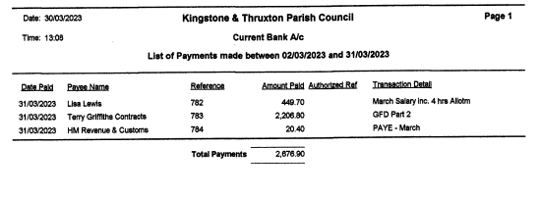

Appendix 2
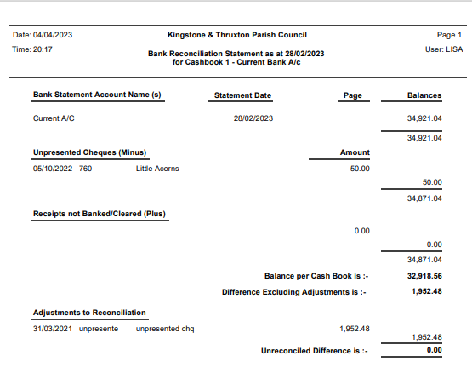
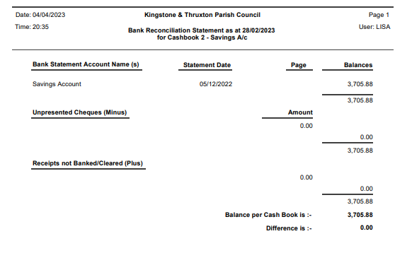
Appendix 3
